ASSIGNMENT 13

1) Create a union of two queries that shows the names, cities, and ratings of all customers. Those
with rating of 200 or greater will also have the words “High Rating”, while the others will have
the words “Low Rating”.

select Cname ,City,'High rating' Rating from CUSTOMERS where Rating >= 200 union select Cname, City, 'Low Rating' Rating from CUSTOMERS where Rating < 200;
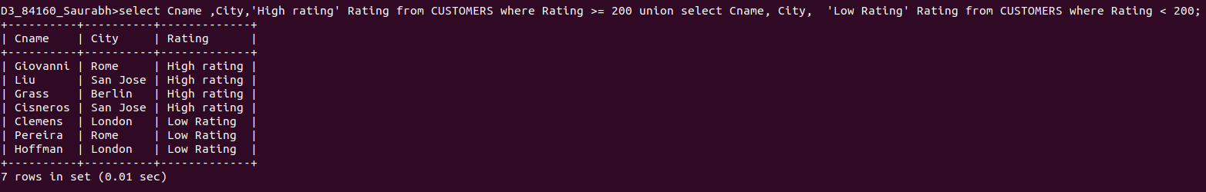

2) Write a command that produces the name and number of each salesperson and each customer with more than one current order. Put the results in alphabetical order.

select SALESPEOPLE.Snum'NUMBER' , Sname'NAME', 'SALESMAN'Sname from ORDERS, SALESPEOPLE where SALESPEOPLE.Snum = ORDERS.Snum group by SALESPEOPLE.Snum, Sname having count(ORDERS.Snum)>1
union
select CUSTOMERS.Cnum, Cname, 'CUSTOMER'Cname FROM CUSTOMERS, ORDERS where CUSTOMERS.Snum= ORDERS.Snum group by CUSTOMERS.Cnum , Cname having count(ORDERS.Snum) >1;
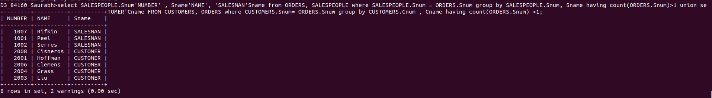

3) Form a union of three queries. Have the first select the snums of all salespeople in San Jose;
the second, the cnums of all customers in San Jose; and the third the onums of all orders on
October 3. Retain duplicates between the last two queries but eliminate any redundancies between either of them and the first.
(Note: in the sample tables as given, there would be no such redundancy. This is besides the point.)

select Snum from SALESPEOPLE where City ='San Jose'
-> union
-> select Cnum from CUSTOMERS where City = 'San Jose'
-> union
-> select Onum from ORDERS where odate = '1990-10-03';

